More JUnit Due Apr 29, 5pm

On BB is a zipped file of a program composed of five classes and an interface. This program is a "soda machine" in the "State" design pattern. The program supports a simple GUI that allows the user to deposit coins, return coins and vend a soda. Sodas cost 50 cents. Clicking the various buttons may or may not move the program from one state to another. That knowledge can be ascertained from examining the state classes of ZeroState, TwentyfiveState and FiftyState. The state pattern is focused through a "context" class. In this case the context class is "SodaMachine".

Your task is to JUnit the heck out of SodaMachine. SodaMachine has essential the same operations as all the other "states" except that its operations do not have parameters (except for SetCurrent). It aggregates a polymorphic instance of State - the interface mentioned above that is implemented by the other state classes. As Hamlet says, "Aye, there's the rub!" The behavior of SodaMachine operations depends upon what's in that polymorphic instance of State.

You must test all three potential outcomes for the implemented interface operations (CoinReturn, CoinSlotDeposit, SodaButton) for each state (ZeroState, TwentyfiveState, FiftyState) and also test SetCurrent. Here is a picture of the by now useless outcome:

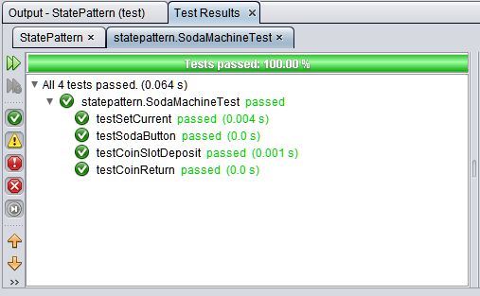

So clearly four tests but in all except testSetCurrent you must test for three possible outcomes as evidenced by the pictures that follow. Also, some operations cause the "state" of the SodaMachine to change. You must verify that the member "current" of SodaMachine (State current;) - it has package visibility - has changed when operations that change it change it.

So here is an example of failing on ZeroState
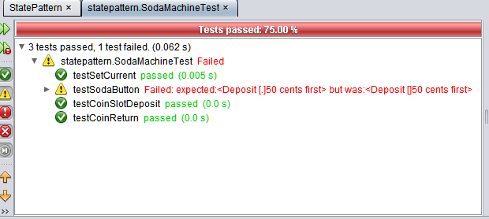

And here is TwentyfiveState failing
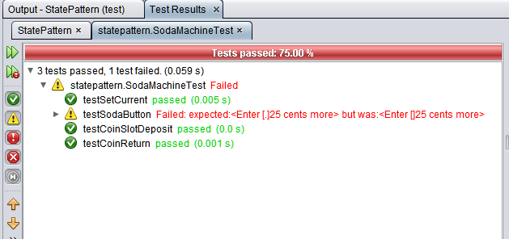

and then FiftyState
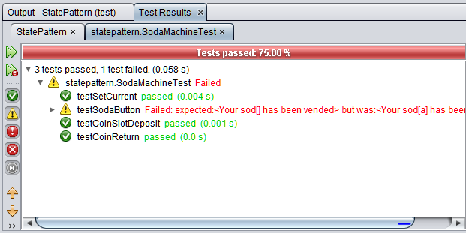

And here an incorrect state is reached
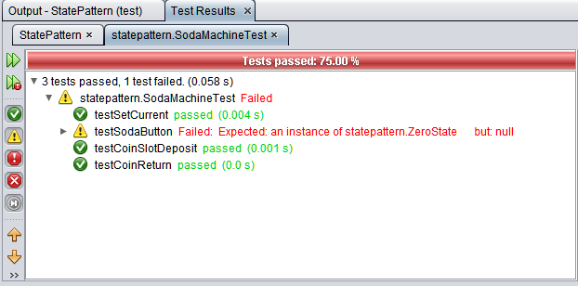

Your output should look like (the test output window to the right bottom)

SetCurrent to FiftyState
SodaButton-ZeroState
SodaButton-TwentyfiveState
SodaButton-FiftyState
CoinSlotDeposit-ZeroState
CoinSlotDeposit-TwentyfiveState
CoinSlotDeposit-FiftyState
CoinReturn-ZeroState
CoinReturn-TwentyfiveState
CoinReturn-FiftyState

Looks like ten tests but it actually there are 19 asserts in the test.

Helpful - https://junit.org/junit4/javadoc/latest/

Hint: how would you assert that an object is of some particular type in Java?

